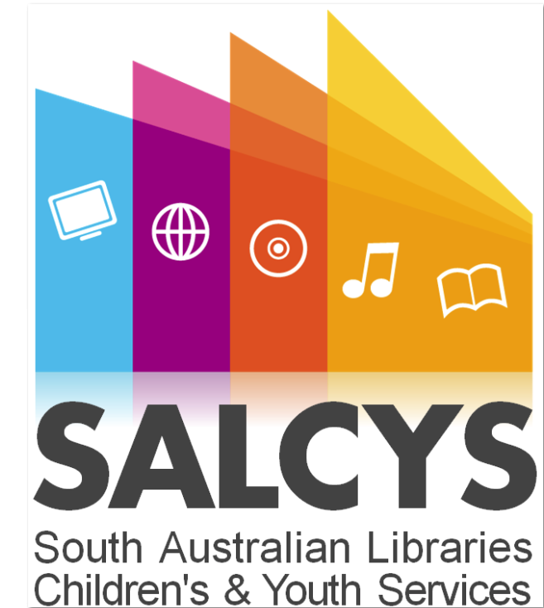

SALCYS Group

Terms of Reference

Version 1
February 2014

DOCUMENT CONTROL
Acknowledgement
This document has been derived from a template prepared by the Department of Premier and Cabinet, Tasmania.
Authors
Name | Function
Veronica Mathews | Coordinator, Public Library Projects
Sascha Hutchinson | Team Leader – Youth & Children’s Library Services  City of Unley – Unley Libraries

Change History
Revision | Revision Description | Date
0.1 | First Draft | 10th Feb 2014
0.2 | Second draft | 13th Feb 2014

Review List
Reviewed By | Comments | Date
SALCYS group |  | 13th Feb 2014

Authorisation
Authorised By | Function | Date
Sascha Hutchinson + SALCYS Group |  | 13th Feb

Contact for Enquiries and Proposed Changes:
Name: Veronica Mathews
Title: Coordinator, Public Library Projects - PLS
Phone: 08 8348 2349
Fax: 08 8223 0964
Email: veronica.mathews@sa.gov.au

Table of Contents

1 Background/Context 5
2 Function of the Library SALCYS Group 5
3 Role of the Library SALCYS Group 5
4 Role of Individual GROUP Members 5
5 General 6
5.1 Membership 6
5.2 Convenor/Chair 6
5.3 Agenda Items 6
5.4 Minutes and Meeting Papers 7
5.5 Frequency of Meetings 7
5.6 Proxies to Meetings 7
5.8 Review Timetable 7
5.9 Dispute resolution 7

- Background/Context

Library staff who specialise in providing library services for children and youth in metropolitan and country South Australian libraries.

- Function of the SALCYS Group

The Function of the SALCYS Group is to share ideas and resources that improve service delivery and raise the profile of children’s and youth services in the SA Public Library Network.
Further functions of the SALCYS Group are:
- Create opportunities for state wide SALCYS events and services.
- Ensure SALCYS members are given opportunities to strengthen knowledge and confidence.
- Maintain a culture that encourages new ideas, invoking action and allowing change.

- Role of the SALCYS Group

The Role of the SALCYS group is to report back to the PLSA Executive and:
- Disseminate information
- Share ideas
- Provide a link to PLSA
- Investigate professional development opportunities
- Liaise with other relevant organisations e.g. Little Big Book Club
- Promotion and advocacy of children's and youth resources to the wider library community
- Provide a support network to library staff working in children's and youth services
- Promote and advocate literacy
- Co-ordinate and support state-wide events
- Networking
- Role of Individual GROUP Members

The Role of the individual members of the SALCYS Group is to:
Share ideas and resources that improve service delivery and raise the profile of children’s and youth services in the SA Public Library Network.
In practice, this means they:
- Help balance conflicting priorities and resources
- Consider ideas and issues raised; and
- Provide suggestions to PLSA and if appropriate to PLS.
- Review SALCYS strategic plan every 2 years

- General
  - Membership

The SALCYS Group will be comprised of any staff interested in Children’s & Youth Services in the South Australian Public Library network.
The following PLS staff members will attend meetings:
• Coordinator, Public Library Projects

The Chair will convene the SALCYS Group meetings and will be nominated for a 2 year period. The SALCYS Group will also nominate a Deputy Chair for the same year period.
If the designated Chair is not available, then the Deputy Chair will be responsible for convening and conducting that meeting. The Deputy Chair is responsible for informing the Chair as to the salient points/decisions raised or agreed to at that meeting.
A member of the PLSA Executive Committee will be part of the committee and will report to the PLSA executive on a quarterly basis..
The secretary will be nominated for a 2 year period or at the discretion of the committee.

  - Agenda Items

All SALCY Group agenda items must be forwarded to the Secretary, SALCYS via email by C.O.B. 10 working days prior to the next scheduled meeting.
The SALCYS Group agenda, with attached meeting papers, will be available on the PLSA Intranet (PLS to load) and the Public Libraries SA Webpage at least 4 working days prior to the next scheduled meeting, and will be sent out via the PLSA mailing list with subject line title “SALCYS Group”.
The Chair has the right to refuse to list an item on the formal agenda, but members may raise an item under ‘Other Business' if necessary and as time permits.

  - Minutes and Meeting Papers

The minutes of each SALCYS Group meeting will be prepared by the Secretary.
Full copies of the minutes, including attachments, will be provided to all SALCYS Group members no later than 30 working days following each meeting. The minutes will also be made available through the PLSA Intranet and the PLSA mailing list with subject line title “SALCYS”.

  - Frequency of Meetings

The SALCYS Group will meet quarterly and will generally be during the months of February, May, September, and November. Meetings will be scheduled around the first week of the first month of each quarter and will be a different day of the week each quarter.

  - Proxies to Meetings

Not applicable

  - Review Timetable
Not applicable

  - Dispute resolution
Not applicable

